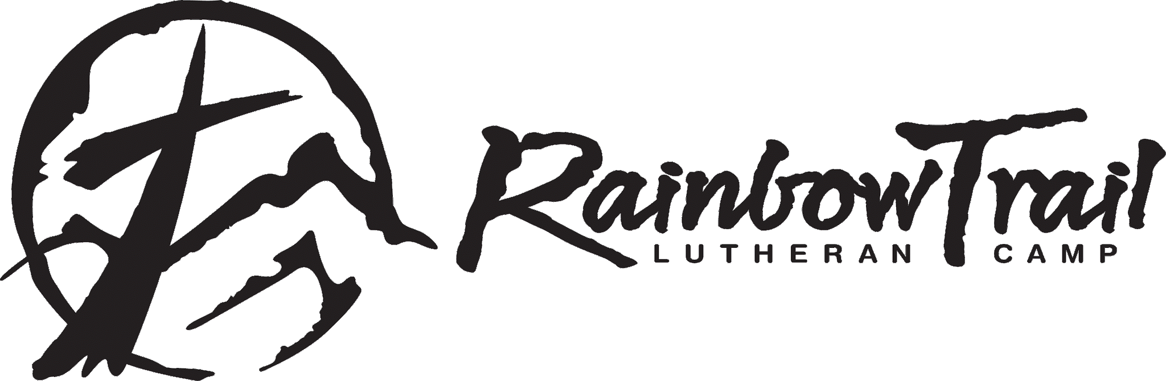

2022 Day Camp Registration Form

For Trinity Lutheran Church, Boulder, Colorado June 27-30, 2022 9am-3pm

Please fill out all information completely and one registration form per camper (even if siblings). Personal information will not be shared with organizations other than Trinity Lutheran Church and camp. You will not receive mailings from RTLC unless you check that you would like to below.

Camper Name: _______________________________________________________ Gender__________

Parent/Guardian Name(s): _____________________________________________________________

Address: _________________________________________________ Grade Entering in Fall: _______

City: ______________________________ State: ____________ Zipcode: _______________________

Phone: (_____)________________________ Emergency Phone: (____)_________________________

Email Address: ________________________________________________________________________

Our Child has permission to take part in all Day Camp activities led by Rainbow Trail Lutheran Camp (Camp) and the hosting congregation (Trinity Lutheran Church). We agree that the Camp, Trinity Lutheran, and their personnel will not be held responsible for accidents arising therefrom. I give Camp and Trinity Lutheran personnel permission to seek medical treatment for my child in case of injury or illness. I also given permission for photos, video, and electronic images to be taken of me or my child and used for by the Camp or Trinity Lutheran Church for promotional purposes without compensation, inspection or approval.

Parent/Guardian Signature ___________________________________ Date _________

Please complete form (one per camper) and print or pdf and return to youth@trinityboulder.org or Trinity Lutheran Church, 2200 Braodway, Boulder, CO 80302 . Cost for week is $100 per registered camper. Please go to www.trinityboulder.org and choose Donate Now. Pay registration fee online or send a check made to: Trinity Lutheran with Day Camp in the memo to above address.
___ Yes, I would like to receive information about Rainbow Trail Lutheran Camp’s Programs!

